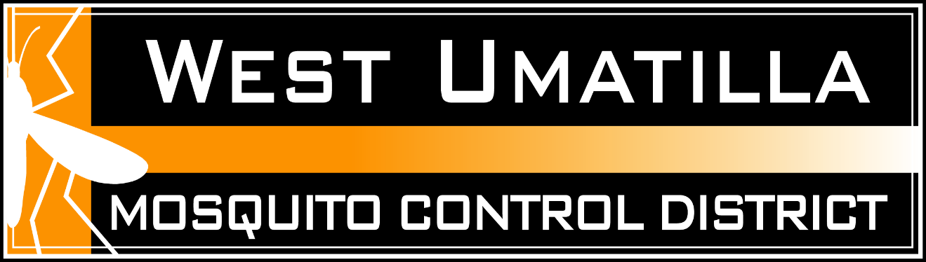

NEWS RELEASE

FOR IMMEDIATE RELEASE

Contact: Randy Gerard, Manager
West Umatilla Mosquito Control District
(541) 567-5201

West Umatilla Mosquito Control District Begins Mosquito Control Activities

Hermiston – The West Umatilla Mosquito Control District has begun implementing its 2025 mosquito control program. The district serves a 525 square mile area in Western Umatilla County, including the towns of Hermiston, Umatilla, Stanfield, and Echo.

The district will target areas of standing water where mosquito larvae thrive. Large water bodies will be sprayed with a helicopter or unmanned aerial vehicles while smaller areas will be treated by hand. To control adult mosquitoes, the district plans to make treatments using truck mounted ultra-low volume foggers. This spraying will be done after sunset in areas of the district that have large populations of adult mosquitoes. In rural areas, the district will begin aerial spraying to control adult mosquitoes when mosquito trap collections indicate the need for large scale spraying. Aerial spraying for adult mosquitoes will be done in the early evening hours just after sunset. Residents of the district that are experiencing a mosquito problem are encouraged to request service by going to www.wumcd.org or by calling the district at 541-567-5201

About 45 species of mosquitoes are found in Oregon. Within the District boundaries, 14 of these species are commonly found in a variety of habitats. The common house mosquito (Culex pipiens), along with the Culex tarsalis, species very common in the District, are targeted as vectors of West Nile virus.

West Nile is primarily a bird disease, and some birds, including magpies, blue jays and crows are especially susceptible. Mosquitoes become infected by feeding on an infected bird and can pass the virus to humans, horses or other hosts when they bite. The public is encouraged to continue to alert district officials when they come across dead birds, so the district can track the spread of the virus.

The risk of West Nile is low but people are encouraged to take appropriate precautions to protect themselves against mosquito bites. Most people who become infected with West Nile Virus do not become ill. Some may develop mild flu-like symptoms such as fever, headache, body aches, and occasionally swollen lymph glands or a rash. In rare cases West Nile may cause encephalitis, or inflammation of the brain. Individuals with severe or unusual headaches should seek medical care as soon as possible.

Residents are encouraged to:

Animal:
• Vaccinate horses for West Nile virus.

Human:
• Wear repellents while outdoors at dusk and dawn when mosquitoes are most active.

• Wear long-sleeved shirts and long pants when in mosquito-infested areas.

• Use mosquito repellents containing DEET, Oil of Lemon Eucalyptus, Picaridin or 2-undecanone, making sure to follow the label directions on the container.

• Use EPA registered residual insect sprays on horses making sure to follow the label directions on the container.

• Make sure all screen doors and windows are in good repair and fit tightly.

Environment:
• Eliminate all sources of standing water which act as a breeding ground for biting mosquitoes. This includes flooded fields, birdbaths, unused wading pools & swimming pools, clogged gutters and old tires. If it holds water for 7 days, it can produce mosquitoes.

• Stock mosquito fish in water troughs and ornamental ponds. They will be available for free at the District Office near the end of May

If for any reason you do not wish to have your property sprayed, please call the mosquito control hotline at 567-5201 and asked to be placed on the no-spray list.

Updates about West Nile Virus in Umatilla County will be released to local media outlets or you can go to the Oregon Department of Human Services web page at: https://public.health.oregon.gov/DiseasesConditions/DiseasesAZ/WestNileVirus/Pages/survey.aspx

Additional information on West Nile is on the Web at:

U.S. Centers for Disease Control and Prevention
http://www.cdc.gov/ncidod/dvbid/westnile/

West Umatilla Mosquito Control District
www.wumcd.org

###

